AI WEATHER WISE API PROJECT TESTING PHASE

PROJECT EXECUTION
The AI WeatherWise backend can be run locally using Node.js. Ensure MongoDB is running and the required environment variables are configured. The REST APIs can be tested using Postman or Thunder Client.

Running the Backend Server
Install all required dependencies:
npm install
Start the development server:
npm start
After successful execution, the server connects to MongoDB and starts listening for incoming API requests
API TESTING
Register API:
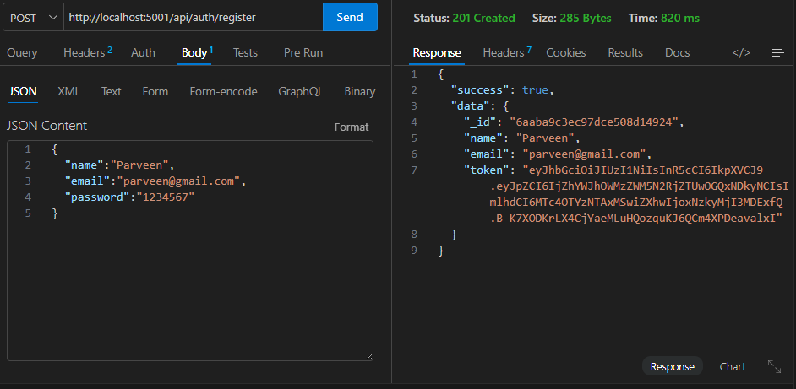

Login API:
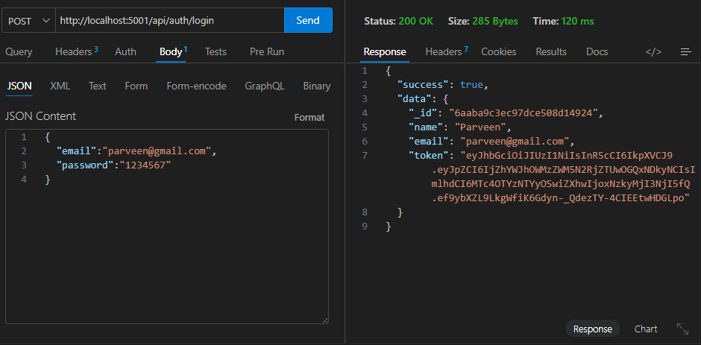
Weather API: 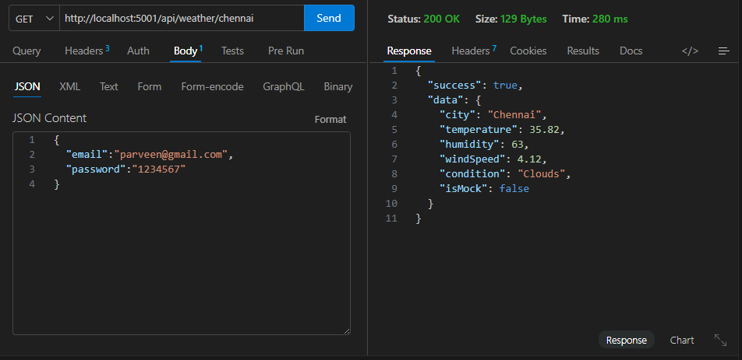

Weather Summary API:
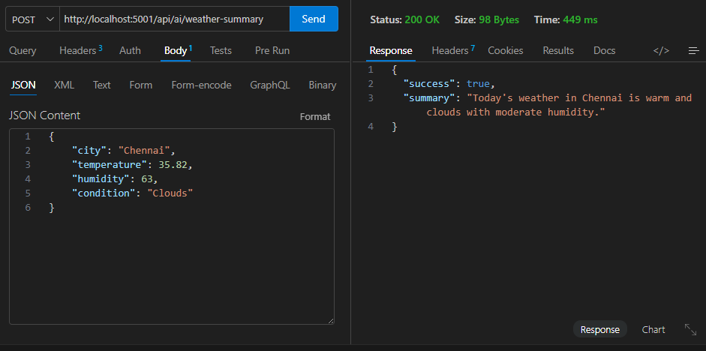

Weather Recommendation API:
